PROJECT REPORT ON

ANALYSIS OF BLINKIT – QUICK COMMERCE PLATFORM
A Case-Based Comparative Analysis of Software Development Life Cycle Models in Quick Commerce Systems
Submitted to
NMAM Institute of Technology, Nitte
(Off-Campus Centre, Nitte Deemed to be University, Nitte - 574 110, Karnataka, India)

In partial fulfillment of the requirements for the award of the
Degree of Bachelor of Technology in
Information Science and Engineering
By
Ayush R NNM24IS051
Under the guidance of Dr. JASON ELROY MARTIS
Associate Professor



1. Introduction and Background

The retail and grocery sector plays an important role in. everyday life, as it provides essential goods required for daily living. Traditionally, grocery shopping was carried out through physical retail stores where customers had to visit shops in person to purchase items. So this approach often involved limitations such as. time consumption, dependence on rescue working hours, long queues. Honestly, and restricted availability of products, and Managing inventory, billing. And customer service manually also created operational challenges for businesses.

With the rapid. growth of digital technologies, internet connectivity. And widespread use of smartphones, there has been a significant go toward online platforms for purchasing goods and services. Honestly, e-commerce applications have enabled. customers to browse products, put orders. And make digital payments from anywhere at any time. This digital transformation has improved convenience for users and has also allowed businesses to simplify operations through automated systems. As a outcome, software systems have become a. critical component in managing large-scale online platforms efficiently.

In recent years, the concept of quick commerce has emerged as an extension of traditional e-commerce. I mean, Quick commerce focuses on delivering essential items, such as groceries and daily necessities, within a super short time frame. Unlike conventional online shopping, these systems rely on location-based inventory, real-time sort processing. And optimized last-mile delivery. True. Actually, Due to the strict delivery timelines involved, quick commerce platforms must handle high volumes of requests while maintaining performance, accuracy. In fact, And reliability.

Blinkit is a quick commerce platform in India that enables users to sort groceries. And essential products through a mobile application and receive deliveries within a limited time window. Blinkit is a quick commerce platform in India that enables users to sort groceries and essential products through a mobile application and receive deliveries within a limited time window. And real-time tracking. The system must operate continuously and efficiently, especially during peak demand periods, to ensure customer satisfaction and business continuity.

Cuz of the time-critical and large-scale nature of quick commerce platforms, software failures can lead to delayed deliveries, financial losses. And reduced user trust. That's why, the use of a well-defined Software Development Life Circle (SDLC) and a structured requirements engineering process is essential [1]. Selecting an appropriate software process model helps in managing risks, handling changing requirements. Basically, And ensuring system quality. To be fair, This report analyzes the Blinkit platform from an SDLC perspective. And compares different software process models to figure out their suitability for quick commerce systems. Exactly. To be fair, This report analyzes the Blinkit platform from an SDLC perspective and compares different software process models to figure out their suitability for quick commerce systems.

2. Objectives :
- To find out and look at different SDLC models such as Waterfall, Incremental. And Boehm’s Twist model
- To get it the role of requirements engineering in the development of quick commerce systems
- To check risk management and go handling in time-critical delivery platforms
- To check the suitability of various SDLC models for large-scale quick commerce applications
- To get ready a simplified requirements document for a Blinkit-like system
- To find out the relevance of Agile and DevOps practices in quick commerce software development

3. Scope:
- A comparative analysis of Waterfall, Incremental. Listen, And Boehm’s Rotate SDLC models
- Examination of the requirements engineering process involved in quick commerce systems
- Identification of functional and non-functional requirements of a Blinkit-like platform
- Well, Analysis of risk management and change handling in rapid delivery applications
- Find out of requirements validation strategies and associated challenges
- Consideration of Agile and DevOps practices in quick commerce software development
4. Methodology:
- A literature check of standard SDLC models such as the Waterfall model, Incremental development model. Actually, And Boehm’s Spiral model was carried out to get their make, advantages. And limitations [1], [2].
- Look, a case find out analysis of the Blinkit platform was performed to spot its operational characteristics, system complexity. Basically, And time-sensitive nature.
- You know, the functional and non-functional requirements of a Blinkit-like quick commerce system were identified based on the platform’s services and user interactions.
- A comparative analysis was conducted to check the suitability of different SDLC models with respect to requirement flexibility, risk management, time constraints. And scalability.
- A simplified requirements document was prepared to mean the core requirements of a quick commerce system.
- You know, Real-world challenges such as demand fluctuations, delivery time constraints. And system reliability were analyzed to get their effect on software development decisions.

5. Overview of the Blinkit Platform:

Blinkit is a quick commerce platform that enables customers to sort groceries and. daily essential products through a digital application and receive deliveries within a short time window. The platform operates by connecting customers, nearby fulfillment centers (commonly referred to as dark stores), delivery partners. And administrative systems through. a single integrated software system [8]. To be fair, Its primary target is to ensure fast and reliable delivery while maintaining accuracy in order fulfillment.

The platform supports multiple types of users, including customers, delivery partners, Rescue managers. And system administrators. Honestly, true. I mean, customers use the application to browse products, put orders, make digital payments. To be fair, And track deliveries in real time. Delivery partners receive task assignments, navigation details, but And sort information through a split interface. Store managers handle inventory updates and sort preparation, while administrators monitor overall system performance, user activity. But basically, And operational metrics.

Exactly. Blinkit’s system is highly dependent on location-based services. Product availability is determined by the customer’s geographical location and the nearest dark rescue. Once an sort is placed, the system performs real-time inventory checks, assigns a delivery partner. Look, and generates an estimated delivery time. Listen, this requires continuous coordination between inventory management systems, sort processing modules, payment gateways. Listen, and delivery tracking services.

From a software engineering perspective, the Blinkit platform is a time-critical and large-scale system. Actually, It must handle a high number of concurrent users, especially during peak hours, festivals, or emergency situations. Any delay or system failure can directly go delivery timelines and customer satisfaction. True. That's why, the platform must ensure high availability, scalability, reliability. Look, and security at all times.

Due to frequent changes in user demand, business strategies. And delivery logistics, the Blinkit platform requires flexible software development practices. Continuous updates, feature enhancements. And system optimizations are necessary to save performance and meet user expectations. This makes Blinkit an appropriate case find out for analyzing different Software Development Life Circle models and their suitability for quick commerce applications.

6. COMPARISON AND ANALYSIS OF SOFTWARE PROCESS MODELS :

6.1. Incremental Development Model :
The Incremental Development Model is a software development approach in which the system is built and delivered in minor functional parts rather than being developed entirely at once [2]. Each increment adds new features to the system. And the software evolves gradually through multiple releases. This model allows early delivery of core functionalities and continuous improvement based on user feedback.

Suitability for Blinkit Functional Requirements :
In the case of a quick commerce platform like Blinkit, the Incremental Development Model is highly suitable because the system consists of multiple independent yet interconnected modules. The platform can be developed in stages, where each increment introduces a specific put of features.

For example, the development can be planned as follows:

Increment 1: User registration, login. And basic profile management
Increment 2: Product browsing and location-based availability
Increment 3: Sort placement and digital payment combination
Increment 4: Delivery partner assignment and real-time sort tracking
Increment 5: Performance optimization, analytics. And administrative features

This approach reflects real-world system growth, where all features are not released simultaneously but are added gradually based on business needs and user demand.

Non-Functional Requirements :

Non-functional requirements such as performance, scalability. And availability can also be improved incrementally. Initial versions of the system may support a limited number of users and delivery locations. As the platform grows, server amount, database optimization. And load-handling mechanisms can be enhanced in later increments. Security features such as improved authentication and data protection mechanisms can also be strengthened over time.

Risk and Go Management :

Quick commerce platforms deal with frequent changes due to fluctuating customer demand, seasonal variations. And operational challenges. The Incremental Development Model supports effective risk and go management by allowing modifications to be made in later increments without affecting the entire system. If an issue occurs in one module, it can be isolated and resolved without disrupting other system components.

For example, changes in delivery logic or pricing strategies can be implemented in specific increments, reducing overall project risk.

Time and Cost Constraints :

The Incremental Development Model enables early let go of core functionalities, allowing the platform to become operational sooner. This helps in generating revenue early and reduces financial risk. Since development and testing are carried out incrementally, defects can be identified and fixed earlier, minimizing rework costs and delays.

Advantages :

- Flexible to changing requirements
- Early delivery of usable features
- Easier testing and debugging of individual modules
- Reduced risk compared to linear models

Disadvantages :

- Combination of multiple increments may become complex
- Requires careful planning and coordination
- Overall system architecture must be well-defined from the beginning

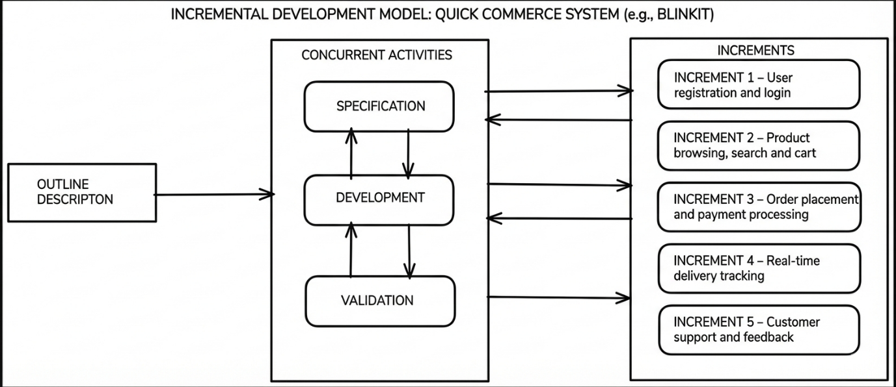
Overall, the Incremental Development Model is well suited for the development of a Blinkit-like quick commerce platform, as it supports gradual system growth, accommodates frequent changes. And enables faster delivery of essential services.

6.2. Boehm’s Spiral Model :

The Spiral Model was proposed by Barry W. Boehm and is a risk-driven software development model that combines iterative development with systematic risk analysis [3]. Unlike linear models, the Spiral Model emphasizes identifying, analyzing. And reducing risks at every stage of development before proceeding to the next phase. Each circle of the spiral represents a development circle that includes planning, risk analysis, engineering. And evaluation.

Suitability for Blinkit Functional Requirements :

For a quick commerce platform like Blinkit, risk management is a critical factor due to strict delivery timelines, real-time inventory handling. And digital payment processing. The Spiral Model is suitable for such systems because it allows developers to find potential risks early and handle them through prototyping and evaluation before full-scale utilize.

In the context of Blinkit, high-risk modules such as payment processing, delivery partner assignment. And real-time tracking can be developed and tested in early rotate cycles. This ensures that potential failures related to transaction security, delivery delays, or system crashes are minimized before deployment.

Non-Functional Requirements :

Non-functional requirements such as security, performance, scalability. And reliability are continuously evaluated in the Spiral Model. For Blinkit, risks such as payment fraud, data breaches, server overload during peak demand. And inaccurate delivery estimates can be analyzed in each iteration. Performance testing and security assessments can be conducted before moving to the next spiral circle, ensuring improve system stability and quality.

Risk and Go Management :

The key strength of Boehm’s Spiral Model lies in its strong focus on risk management. In quick commerce systems, requirements often go due to business strategies, customer behavior. And operational constraints. The Spiral Model supports such changes by allowing reassessment of requirements and risks at every circle. This makes it easier to incorporate new features or modification existing functionalities without affecting the entire system.

For example, changes in delivery logic or pricing mechanisms can be evaluated through prototypes before final implementation, reducing the risk of system failure.

Time and Cost Constraints :

The Spiral Model generally requires higher initial cost and time because of repeated risk analysis, prototyping. And validation activities. It also demands experienced personnel to accurately find and lower risks. However, for complex and large-scale systems like Blinkit, this additional effort helps cut the long-term cost of failures, rework. And system downtime.

Advantages :

- Strong focus on risk identification and mitigation
- High quality and reliability of the final system
- Supports frequent requirement changes
- Suitable for large and complex systems

Disadvantages :

- Higher development cost compared to simpler models
- Time-consuming due to repeated analysis and prototyping
- Requires skilled and experienced development teams

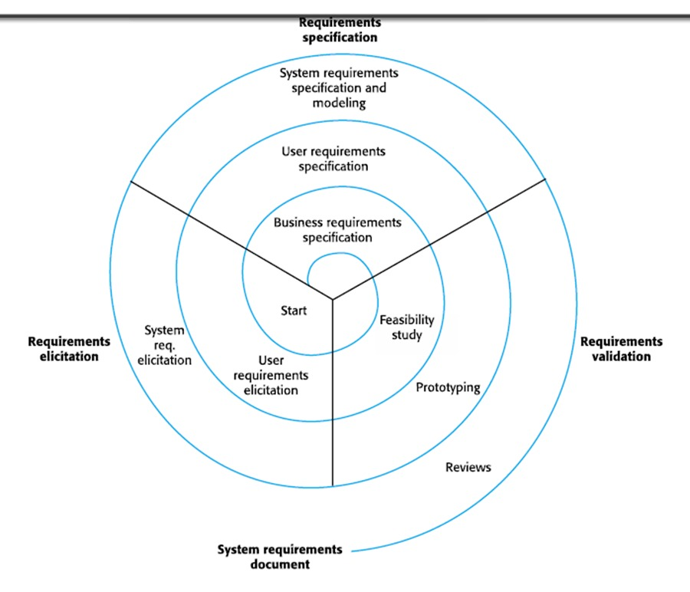

Overall, Boehm’s Spiral Model is highly suitable for critical components of a Blinkit-like quick commerce platform, especially modules involving payments, real-time tracking. And system scalability, where failure can have significant operational and financial effect.

Waterfall Model :

The Waterfall Model is a traditional software development approach that follows a linear and sequential process [2]. In this model, the software development life circle is divided into clearly defined phases. And each phase must be completed before moving to the next one. Typical phases have requirements analysis, system think ahead, utilize, testing, deployment. And maintenance. Due to its structured nature, the Waterfall Model emphasizes thorough documentation and upfront planning.

Suitability for Blinkit Functional Requirements :

The Waterfall Model is most suitable when system requirements are well defined and unlikely to go during development. In the context of a quick commerce platform like Blinkit, certain basic and stable modules can be developed using the Waterfall approach. For example, components such as user registration, basic order placement workflow, or static administrative functions may not require frequent changes once finalized.

However, Blinkit operates in a highly active environment where customer expectations, delivery mechanisms. And business strategies obtain bigger rapidly. The rigid generate of the Waterfall Model makes it difficult to accommodate such changes after the requirements phase is completed. As a outcome, its applicability to the entire Blinkit system is limited.

Non-Functional Requirements :

One of the strengths of the Waterfall Model is its focus on full documentation, which can assistance deal with non-functional requirements such as compliance, security policies. And system standards. Clear documentation ensures that performance, reliability. And security expectations are defined early in the development process.

However, verifying non-functional requirements like scalability and performance only at later stages can be risky for a time-critical platform. Any issues discovered during testing may require significant rework, increasing development effort and cost.

Risk and Move Management :

Risk and go management in the Waterfall Model is relatively weak. Since the model assumes that requirements remain stable, any changes identified after initiate can be costly and time-consuming. For Blinkit, where frequent changes in delivery logic, pricing models. And operational workflows are common, this lack of flexibility poses a major dare.

Additionally, risks related to performance bottlenecks or system combination are often identified late in the development circle, reducing the ability to respond effectively.

Time and Cost Constraints :

The Waterfall Model generally requires a longer development time before the system becomes operational, as all phases must be completed sequentially. This delays the let go of usable features and prevents early feedback from users. If requirement changes occur later in the project, the cost of modification increases significantly.

While the Waterfall Model may assist control costs in projects with stable requirements, it is less suitable for fast-paced platforms like Blinkit, where early deployment and continuous improvement are essential.

Advantages :

- Simple and easy to obtain structure
- Clear phase-wise documentation
- Suitable for minor and stable modules

Disadvantages :

- Inflexible to changing requirements
- Late detection of defects
- Not suitable for highly active systems

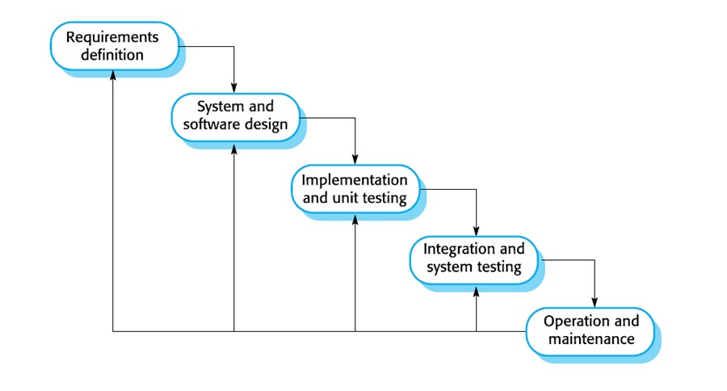

Overall, the Waterfall Model has limited applicability for a Blinkit-like quick commerce platform. While it can be useful for minor and stable components, it is not suitable for the conclude system due to its rigid generate and poor adaptability to go.

7. Comparison of Software Development Life Cycle Models :

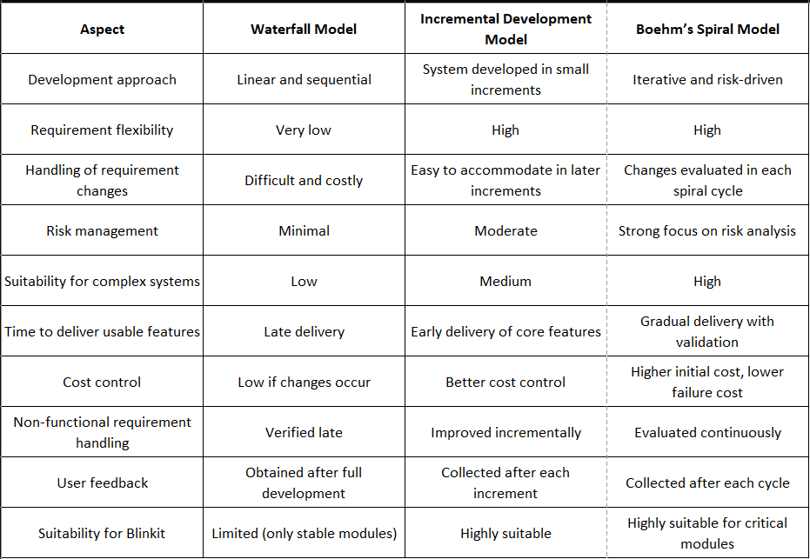

Overall, a hybrid approach combining the Incremental Development Model and Boehm’s Spiral Model is most suitable for a Blinkit-like quick commerce platform. Incremental development supports rapid feature delivery and adaptability, while the Spiral Model ensures effective risk management and system reliability. The Waterfall Model can be selectively used for stable and well-defined modules where requirement changes are minimal.

8. Requirements Engineering Process :

Requirements Engineering is a critical phase in the Software Development Life Circle, as it focuses on identifying, analyzing, documenting. And validating the needs of stakeholders. A well-defined requirements engineering process ensures that the developed system meets user expectations and business objectives [1], [6]. For large-scale and time-sensitive platforms like Blinkit, improper or incomplete requirements can lead to delivery delays, system failures. And poor user feel.

In a quick commerce platform, requirements are often dynamic due to changing customer behavior, business strategies. And operational constraints. Therefore, a structured requirements engineering process is essential to manage frequent changes while maintaining system quality and reliability.

The requirements engineering process for a Blinkit-like quick commerce system can be broadly divided into the following stages:

8.1. Requirements Elicitation :

Requirements elicitation involves gathering requirements from various stakeholders associated with the system. In the case of Blinkit, stakeholders have customers, delivery partners, rescue managers. And system administrators. Techniques such as stakeholder interviews, user surveys, observation of delivery workflows. And analysis of existing e-commerce systems can be used to spot both functional and non-functional requirements. Effective communication during this stage helps cut ambiguity and misunderstandings.

8.2. Requirements Analysis and Specification :

Once the requirements are gathered, they are analyzed to find conflicts, inconsistencies. And feasibility issues. During this phase, requirements are categorized into functional and non-functional requirements. Functional requirements define system behavior such as sort placement, payment processing. And delivery tracking, while non-functional requirements deal with performance, scalability, security. And reliability. The analyzed requirements are then documented clearly in a requirements specification document to ensure a common understanding among all stakeholders.

8.3. Requirements Modeling :

Requirements modeling provides a visual and structured representation of system requirements. Models such as utilize case diagrams, data flow diagrams. And process flow diagrams can be used to say interactions between users and the system. For Blinkit, modeling helps in understanding complex interactions between inventory systems, delivery partners. And customers. And supports improve system think ahead decisions.

8.4. Requirements Validation :

Requirements validation ensures that the documented requirements accurately say stakeholder needs and are feasible to utilize. Validation techniques include reviews, walkthroughs, prototyping. And stakeholder feedback sessions. In quick commerce platforms, validating requirements early helps find issues related to delivery time constraints, system performance. And user have before utilize begins.

8.5. Requirements Management :

Requirements management involves handling changes to requirements throughout the project lifecycle. Since Blinkit operates in a changing environment, new features and modifications are common. A proper requirements management process helps track changes, check their impact. And rescue consistency using tools such as version control systems and requirement traceability matrices.

Overall, a systematic requirements engineering process plays a vital role in ensuring the successful development of a Blinkit-like quick commerce platform. It helps lower risks, generate improve system quality. And ensure that the final product meets both business and user requirements.

9. Expanding SDLC Considerations :

Modern software systems often require development approaches beyond traditional SDLC models to handle rapid changes, continuous deployment. And high user expectations. For time-critical platforms like Blinkit, integrating additional development practices such as Agile methodology and DevOps becomes essential to ensure system adaptability, reliability. And faster delivery of features.

Agile Methodology in Blinkit :

Agile methodology emphasizes iterative development, continuous feedback. And close collaboration between stakeholders and development teams. In a quick commerce platform, user requirements and business strategies frequently obtain bigger due to changing customer behavior and market conditions. Agile practices assist handle these changes by allowing features to be developed in short iterations and released frequently [4], [7].

For Blinkit, Agile methodology supports rapid enhancement of features such as sort tracking, delivery optimization. And user interface improvements. Regular feedback from customers and delivery partners enables teams to spot issues early and generate improve system usability. However, Agile requires active stakeholder involvement and disciplined team coordination to be effective.

DevOps Integration :

DevOps focuses on improving collaboration between development and operations teams to allow faster and more reliable software delivery. Through practices such as continuous combination, continuous deployment. And automated testing, DevOps helps reduce system downtime and deployment failures [5].

In the context of Blinkit, DevOps mixing allows frequent updates without disrupting ongoing services. Automated monitoring and rollback mechanisms assist rescue system stability, which is critical for platforms that operate continuously. DevOps practices also support faster resolution of bugs and performance issues, ensuring consistent delivery experiences for users.

Relevance to Quick Commerce Systems :

The combination of Agile and DevOps practices complements traditional SDLC models by enhancing flexibility and operational efficiency. While models like Incremental and Spiral define the overall development generate, Agile and DevOps generate improve execution by enabling faster releases, improve quality control. And continuous improvement.

Overall, expanding SDLC considerations through Agile and DevOps practices helps Blinkit modification to changing requirements, generate improve system reliability. And say competitive advantage in the fast-paced quick commerce environment.

10. Ethical Considerations :

Ethical considerations play an important role in the development and operation of digital platforms that handle user data and give essential services. Quick commerce platforms like Blinkit interact with a large number of users and process sensitive information such as personal details, location data. And payment information. So, ethical practices must be followed throughout the software development and deployment process to ensure user trust and social responsibility.

Data Privacy and Security :

One of the primary ethical concerns in quick commerce platforms is the protection of user data. The system must ensure that personal information, sort history. And payment details are stored and processed securely. Unauthorized access, data breaches, or misuse of customer data can lead to loss of trust and legal consequences. Ethical software development requires the utilize of secure authentication mechanisms, encryption. And compliance with data protection regulations.

User Consent and Transparency :

Users should be clearly informed about how their data is collected, stored. And used. Obtaining user consent before collecting personal or location-based information is an important ethical requirement. Transparency in privacy policies and clear communication concerning data usage helps users generate informed decisions and builds confidence in the platform.

Fair Access and Non-Discrimination :

Quick commerce platforms should ensure fair access to services without discrimination. Ethical considerations have avoiding biased algorithms that may unfairly prioritize or restrict services based on location, user behavior, or delivery partner selection. Pricing strategies and service availability should be designed to promote fairness and stay away from exploitation during high-demand situations.

Ethical Utilize of Technology :

Advanced technologies such as artificial intelligence and data analytics are often used to generate improve operations in quick commerce platforms. Ethical utilize of these technologies involves ensuring that automated decision-making systems execute not negatively effect users or delivery partners. For example, delivery partner workload distribution and performance monitoring should be conducted responsibly and without unfair treatment.

Effect on Workers and Society :

Quick commerce platforms rely heavily on delivery partners for last-mile delivery. Ethical considerations have ensuring reasonable working conditions, fair compensation. And transparent performance evaluation mechanisms. From a broader societal perspective, the platform should try to operate responsibly without causing unnecessary social or environmental harm.

Overall, ethical considerations are essential for maintaining trust, ensuring compliance. And promoting responsible software development. By addressing issues related to privacy, fairness, transparency. And ethical utilize of technology, a Blinkit-like quick commerce platform can give reliable services while adhering to ethical standards.

11. Emerging Technologies in Blinkit :

Modern quick commerce platforms increasingly rely on emerging technologies to generate improve efficiency, accuracy. And user have. Some of the key technologies relevant to a Blinkit-like platform are discussed below.

Artificial Intelligence (AI) :

- Used for demand prediction and inventory planning
- Helps generate improve delivery routes and cut delivery time
- Supports personalized product recommendations
- Enables automated customer support through chatbots

Internet of Things (IoT) :

- Used for real-time inventory tracking in dark stores
- Supports monitoring of storage conditions for perishable goods
- Enables faster sort processing through smart devices
- Improves coordination between inventory and delivery systems

Blockchain Technology :

- Provides secure and transparent transaction records
- Helps prevent data tampering and fraud
- Improves trust in payment and order history management
- Supports secure sharing of records between system components

Overall, the utilize of emerging technologies enhances the performance, scalability. And reliability of quick commerce platforms. When applied ethically and responsibly, these technologies assist Blinkit generate improve service quality while managing operational complexity [6].

12. Alternative SDLC Models :

Apart from the commonly used SDLC models, certain alternative models can also be considered for specific phases of a quick commerce platform like Blinkit.

Prototyping Model :

- Focuses on building an initial prototype of the system
- Helps in understanding user interface and user have requirements
- Allows early user feedback before full-scale development
- Useful for validating order flow, tracking screens. And app navigation

Limitation:

- Excessive prototyping may increase development time and cost

V-Model :

- An extension of the Waterfall Model with emphasis on verification and validation
- Each development phase is associated with a corresponding testing phase
- Ensures high quality and correctness of the system
- Suitable for modules requiring strict validation and reliability

Limitation:

- Limited flexibility to accommodate frequent requirement changes

These alternative SDLC models can be selectively used along with primary development approaches to generate better system quality and validation in specific components of a Blinkit-like quick commerce platform.

13. Conclusion

This report presented a case-based comparative analysis of different Software Development Life Circle models in the context of a quick commerce platform similar to Blinkit. The learn examined the Waterfall Model, Incremental Development Model. And Boehm’s Spiral Model to obtain their suitability for developing time-critical and large-scale delivery systems.

The analysis showed that the Waterfall Model, while structured and well-documented, is suitable only for minor and stable modules due to its rigid nature and limited ability to handle frequent requirement changes. The Incremental Development Model proved to be more appropriate for quick commerce platforms, as it supports gradual feature development, early delivery of core functionalities. And continuous improvement based on user feedback. Boehm’s Spiral Model was found to be highly effective for managing risks associated with critical components such as payment processing, real-time tracking. And system scalability.

The report also highlighted the importance of a strong requirements engineering process in ensuring system quality and reliability. Proper requirements elicitation, analysis, validation. And management assist cut ambiguities and cut down development risks. In addition, the mixing of Agile and DevOps practices was identified as beneficial for improving adaptability, deployment speed. And operational stability.

Overall, a hybrid development approach combining the Incremental Development Model and Boehm’s Spiral Model is most suitable for a Blinkit-like quick commerce platform. Such an approach balances flexibility, risk management. And efficiency, enabling the system to modification to changing business needs while maintaining high performance and reliability.

14. APPENDIX :

Tools Used in Requirements Management and Development
- JIRA – Used for tracking requirements, tasks, and change requests
- Trello – Used for task organization and workflow visualization
- GitHub – Used for version control and documentation management
- draw.io – Used for creating SDLC and process diagrams

Github : https://github.com/Ayush0179/Blinkit-SDLC-Case-Study

15. References :

- I. Sommerville, Software Engineering, 10th ed. Boston, MA, USA: Pearson, 2016.

- R. S. Pressman and B. R. Maxim, Software Engineering: A Practitioner’s Approach, 8th ed. New York, NY, USA: McGraw-Hill, 2015.

- B. W. Boehm, “A spiral model of software development and enhancement,” Computer, vol. 21, no. 5, pp. 61–72, May 1988, doi: 10.1109/2.59.

- K. Beck et al., “Manifesto for Agile Software Development,” 2001. [Online]. Available: https://agilemanifesto.org/

- L. Bass, I. Weber, and L. Zhu, DevOps: A Software Architect’s Perspective. Boston, MA, USA: Addison-Wesley, 2015.

- P. Bourque and R. E. Fairley, Eds., Guide to the Software Engineering Body of Knowledge (SWEBOK), Version 3.0. IEEE Computer Society, 2014.

- S. Jalali and C. Wohlin, “Global software engineering and agile methods: A systematic review,” Journal of Software: Evolution and Process, vol. 24, no. 6, pp. 643–659, Aug. 2012, doi: 10.1002/smr.567.

- Blinkit, “About Us – Quick Commerce Platform,” Blinkit.com. [Online]. Available: https://blinkit.com/about

DECLARATION OF ACADEMIC INTEGRITY: I hereby declare that this assignment is. my original work and hasn't been copied or plagiarized from any source. But all references and resources used have been properly cited, and Any ambiguities will lead to forfeiting my marks.

Student Signature : Submission
Date :

16 February 2026

